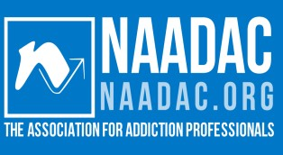
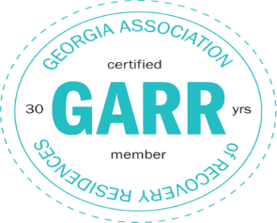
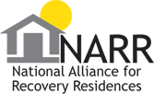

Contact Us
PO Box 354 Baxley, GA 31515
Phone: 912-366-7777
Email: mike@twentyfour7houseinc.com
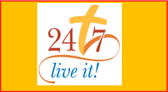
Web: www.twentyfour7houseinc.com

BEACON
1
2
/20
2
3

PO Box 354
Baxley, GA 31515

Christmas in Recovery, A view from the Assistant Director
As we approach the holiday season, it is important to acknowledge and support those who are in recovery from addiction. The holidays can be a challenging time for individuals who are on the path to recovery, as they may face triggers and temptations that can jeopardize their progress. Being in recovery during the holidays means making a commitment to prioritize one's health and well-being. It means embracing a lifestyle that promotes sobriety, self-care, and positive coping mechanisms. It means finding strength in the face of adversity and choosing to surround oneself with a supportive network of friends, family, and recovery communities, we call this “Staying in the Herd”. During this season, let us come together as a community to offer compassion, understanding, and encouragement to those in recovery.
Remember, recovery is a lifelong journey, and the holidays can present unique challenges. By offering support, understanding, and a sense of belonging, we can make a positive difference in the lives of those in recovery.
At 24/7 House inc., we provide long term comprehensive support and rehabilitation services to individuals struggling with drug and alcohol addiction. Our mission is to empower individuals on their journey to recovery and help them rebuild their lives by teaching them about addiction and how to manage situations they may encounter.
We work the 12- steps and we are a Christ-Based facility. As you may know, we have been blessed to be able to follow God’s Will and expand the 24/7 House! We now have 4 buildings that will house the residents. Our program is now a minimum of 18 Months. With the structure, the Spirituality you encounter while being here, the classes teaching about addiction, counselors on board and available day or night, community support and now the chance to stay and transition back out into society, we will be able to help more addicts seeking help and will be able to raise the percentage of gaining and sustaining long term recovery. The residents that are here for 12 months will move into the 3rd Phase, which is transition phase, where they are still in the program and have structure and rules to follow but they can have more freedom, mend broken relationships within their families, find a home church, go out and live life enjoying recovery and be able to come back to the safe environment. The

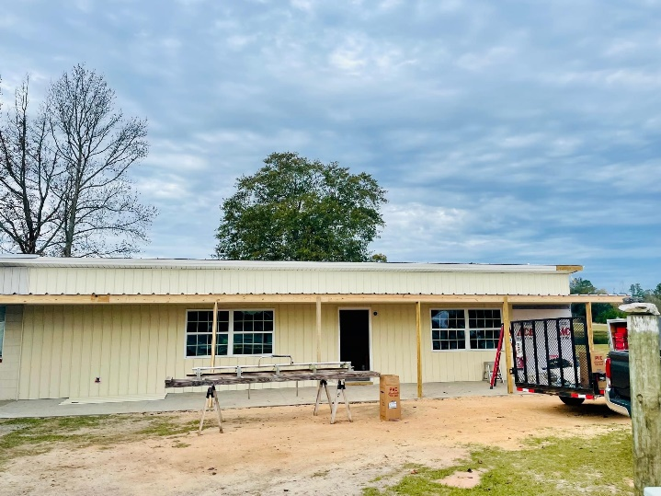

Women’s Transition House Needs
- (up to 6) Twin size beds and beddings for them
- Toiletries (bath rug, toilet paper holders etc....)
- Rugs and trash cans
- Living room furniture (couch, love seats etc...)
- Playroom Décor for children’s room
- Dressers/ nightstands for each room
- Lamps (up to 6)
- Kitchen pots and pans, plates, and cups
- Coffee pot and coffee cups
Any kind of donation will be helpful and will bless us tremendously.
The outpouring of support from the community has been truly inspiring and we are greatly humbled by your generosity.
Again, Thank you to all who have already donated and supported
24/7 House in this journey of walking in God’s will and helping those in need. We are honored to have such a caring and compassionate community standing by our side.

Testimonies From Women at 24/7 House Inc.
This Christmas I have something I've not had in a long time, recovery, and hope. When I first got here, I believed I was broken beyond repair. I would never be able to change after 35 years of active addiction. I was wrong God made a way for it to be possible. He loved me until I was able to love myself. Through struggles and hard work, He and I have hope for a beautiful future. The transition house here 24/7 will provide me with a safe place to continue my recovery, all the while giving me freedom to step outside and practice my tools of recovery without just being thrown into the world. It will give me a place to continue healing and learning to walk the walk through this life. It's a place where when life happens, I can find safety and peace, this wouldn't be possible without the transition house for six months. I have an anchor for my soul. I am forever grateful this Christmas I'm thankful for new beginnings God and 24/7 House. This transition house is a blessing to me and all the women coming through the program and will be for years to come. It is our Christmas miracle. – Kim (set to move into the New women’s House in March)
This Christmas as we celebrate the birth of Jesus my Lord and savior I have so very much to be thankful for! I'm a resident here at the 24/7 house working a 12-step recovery program from addiction, this program has brought so much to my life as well as saving it and joy to my heart. I've witnessed so many wonderful things that God is doing and the lives that are being restored here in the program is astonishing. After 12 months here in the program women, such as myself, will now have the amazing opportunity to transition out to the new 3rd phase house located here on the property. It's there where we will continue to grow, and work on our recovery in a safe environment. We can work, save money, have a car, phone, and if we have kids, they will be able to visit on weekends. So much hard work and love has been put into the building at this house by so many in our community. As I close, I want to say thank you, Merry Christmas, and if you are ever out by the 24/7 recovery house some night look, please into the sky over our house here and you will see so many stars. There's one that shines so brightly, not sure what it is called, but I want to think of it as the one that was shining so brightly down on baby Jesus in Bethlehem the day he was born. ---------Jennifer
women will be able to have their children visit them for a weekend and stay in the safe environment we provide.
The support and assistance we receive from our community plays a vital role in fulfilling our mission and making a lasting impact on the lives of those in need.

Running a drug and alcohol rehab nonprofit requires significant financial resources to provide quality care and support services. Since we do not take any government money and we haven’t received any grants, Community support in the form of donations, and fundraising helps us to continue helping those in need, not only while they are here but as they continue their recovery. The generosity of our community ensures that financial barriers do not prevent individuals from accessing the help they need to live life in recovery because we believe in helping those that WANT the help and in most cases, those that want the help have minimum support at that point in their addiction. Community support is vital to 24/7 House. Together, we can make a lasting impact on the lives of individuals in recovery and contribute to a healthier and more resilient community. We are grateful for the ongoing support and commitment of our community in helping us fulfill God’s mission. We are excited to see what the new year has in store for 24/7 House and the impact on people’s lives. We are truly Blessed beyond measure to live in Appling County and have the continued support of this community.
Wishing you a joyful and Blessed holiday season!
-Jessica Kabbes, NCPRSS
Women’s Counselor
Assistant Director

Testimonies From Women at 24/7 House Inc.
I don't remember ever having an enjoyable Christmas, during my addiction Christmas was just a regular normal day but this Christmas I can say that I truly have joy. I look forward to Christmas this year this is the first year I've been sober or not locked up and it couldn't have been possible if it wasn't for God placing me here at 24/7 house. Being here has changed my life and my outlook on life. It has shown me what true support is and they have loved me until I learned to love myself. But it doesn't stop here, I now have hope for future holidays and Christmas and not to mention the transition house. I'm super excited about it because I will have the chance to use the tools I've learned and still have a safe place to come back to because who knows what would happen if I stepped right back into the world after being here 12 months. So, instead I can have a little more freedom, time to save money, and still have a healthy environment to come back to. It couldn't have worked out better. Thank you God! – Deidra (Set to move into the new women’s house in March)
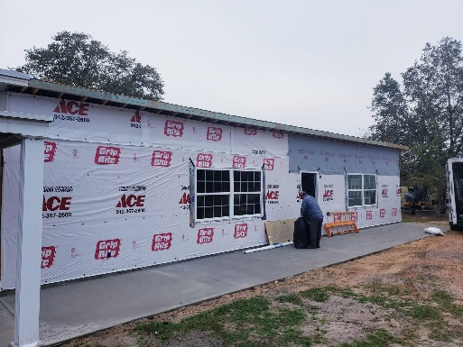
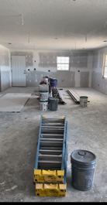

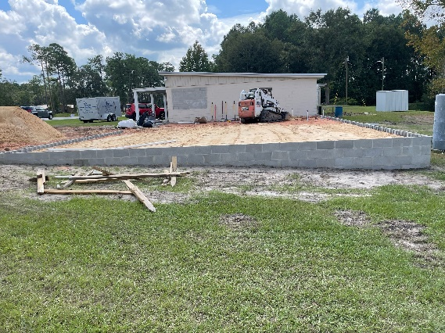

Having a transition house to go to is a blessing, I’m extremely grateful for I feel it’s a necessity for the other girls and myself so that we can transition back into society. It can be a big challenge to leave here and go straight into the real world Without a place like the transition house. My life is completely different than when I first came in and started my recovery journey. To learn how to deal and cope with the stress and difficulties life can throw at you without running to drugs to fix all my problems. The transition house will make the process of entering back into society a lot smoother and take a lot of stress away. Being in recovery during Christmas is very exciting and shows me how wonderful and loving God is. I feel here in the moment and not off somewhere else in my head thinking of drugs I can enjoy Christmas this year. Knowing I’m doing the right thing to be clean and sober, clear minded and present to feel a part of, to be able to get my son gifts and not have someone else buy them and put my name on it. I’m just extremely grateful for where God has brought me and for 24/7 House. – Alivia

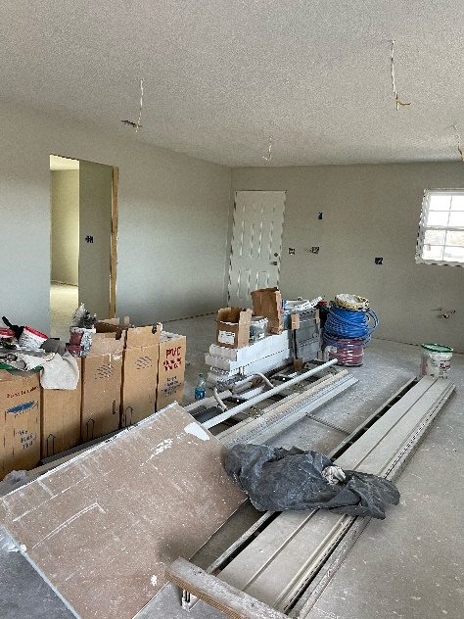
Christmas this year is going to be a lot different. It’s one of the first years I've been away from my kids but more importantly it's going to be the first one I've had in a long time since I can remember that I'm going to be sober for. So, although I'll be sad about being away from my kids, I'm also so full of gratitude because I have so much joy today. I'm so very excited to be at 24/7 house and to be learning a new way to live and I'm getting a clearer head and becoming a better person for myself and my kids. This time next year I'll get to be at this new transition house that they have worked so hard on and once I'm there my kids will be able to come and spend the weekend with me in a healthy and safe environment. Watching and hearing about the transition house makes me that much more excited about this journey I'm on. It is good to know that after 12 months in the program we have had to go to and that we won't be put out into the real world first. We get that extra time to make sure that we are ready for it and can handle it. The 24/7 House and God has helped me change my life in such a good way that I've never imagined was possible. Even though I haven't been here that long, I can already see and feel such a big difference in the way I feel, see things, and think. It is truly amazing, I'm so grateful for this opportunity and this program. All the staff and women who love me and support and encourages me everyone at the 24/7 House has been a huge blessing in my life. -Angela

